# Supervised Learning

## Libraries

## Load Data

path=r'https://cf-courses-data.s3.us.cloud-object-storage.appdomain.cloud/IBMDeveloperSkillsNetwork-ML0101EN-SkillsNetwork/labs/Module%202/data/FuelConsumptionCo2.csv'

df = pd.read_csv(path)

df.head()

## Pre-Processing Data

### Column dtypes

df.dtypes

#### Dummy Variables (One Hot Encoding)

dummy = pd.get_dummies(df, columns=df.columns[(df.dtypes == 'object') | (df.dtypes == 'category')])

df = pd.DataFrame(data=dummy)

df.head()

OR

df['Gender'].replace(to_replace=['male','female'], value=[0,1],inplace=True)

df.head()

#### Object -> Integer

df = df[pd.to_numeric(df['BareNuc'], errors='coerce').notnull()]

df['BareNuc'] = df['BareNuc'].astype('int')

df.dtypes

### Feature Scaling

Ensures all features are weighed the same in the algorithm.

#### Standardization (Recommended)

from sklearn.preprocessing import StandardScaler

X= preprocessing.StandardScaler().fit(X).transform(X)

X

# X = pd.DataFrame(data=X, columns=df.columns[1:])

# X.head()

= 0

= 1.

#### Normalization

from sklearn.preprocessing import MinMaxScaler

X = MinMaxScaler().fit_transform(X)

X

# X = pd.DataFrame(data=X, columns=df.columns[1:])

# X.head()

## Training, Validating, and Testing the Model

from sklearn.model_selection import train_test_split

X_train, X_val_and_test, y_train, y_val_and_test = train_test_split(X, y, test_size=0.3, random_state=4)

X_val, X_test, y_val, y_test = train_test_split(X_val_and_test, y_val_and_test, test_size=0.5, random_state=4)

print(X_train.shape, X_val.shape, X_test.shape, y_train.shape, y_val.shape, y_test.shape)

Training Accuracy: Accuracy on the Training data set (overfit/underfit)

Out-of-Sample Accuracy: Accuracy on future data

1. Train and Test Model on the Same Data Set
   * ↑ Training Accuracy
   * ↓ Out-of-Sample Accuracy
2. Train 70% / Validation 15% / Test 15%
   * --- Acceptable Training Accuracy
   * ↑ Higher Out-of-Sample Accuracy

### K-Fold Cross Validation

## Algorithm

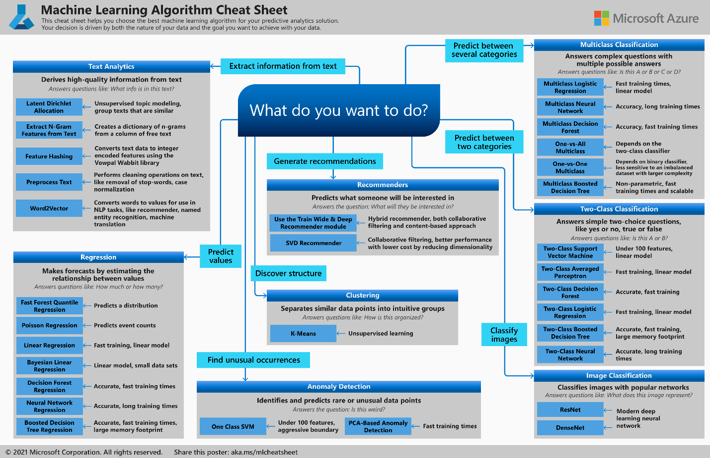

### Regression

Predict Values

#### Linear Regression

Prediction Set (1xn)

Predicted Dependant Value

Actual Dependant Value

Mean of all Actual Dependant Values

Parameters Matrix (nx1)

n Number of features

Feature Set (1xn)

Feature i

##### Algorithms

###### Linear Regression

1 Variable

###### Multiple Linear Regression

Multiple Variables

###### Non-Linear Regression

###### Polynomial Linear Regression

##### Optimization

###### Error Functions

Cost Function Minimizes the average error over all training examples.

Loss Function Minimizes the error of a single training example.

Loss Functions

Minimizes the error of a single training example.

0 - ꚙ Negatively Orientated

More robust to outliers. Less stable.

0 - ꚙ Negatively Orientated

Less robust to errors. More stable.

0 - ꚙ Negatively Orientated

, otherwise

Best. Quadratic for small errors. Linear for high errors.

Cost Functions

Cost Function Minimizes the average error over all training examples.

0 - ꚙ Negatively Orientated

More robust to outliers. Less stable.

0 - ꚙ Negatively Orientated

Less robust to errors. More stable.

0 - ꚙ Negatively Orientated

###### Optimization Algorithms

|  |  |
| --- | --- |
| **Gradient Descent** | **Ordinary Least Squares (Normal Equation)** |
| m>10k | m<10k |
| Kn2 Algorithm Complexity | Kn3 Algorithm Complexity |
| No Regularization | Regularization (non-invertible) |
| Iterative | Analytical |
| Must chose Learning Rate | No Learning Rate |
| Feature Scaling can be used | No need for Feature Scaling |

* + - * 1. Gradient Descent (>10k)

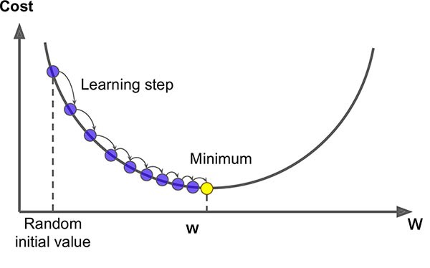

* + - * 1. Ordinary Least Squares (Normal Equation) (<10k)

#### Bayesian Linear Regression

#### Neural Network

#### Decision Tree

#### Decision Forest

#### Fast Forest Quantile

#### Poisson Regression

### Classification

#### Support Vector Machines (SVM)

#### Logistic Regression

#### K-Nearest Neighbor (KNN)

#### Neural Network

#### Decision Tree

#### Decision Forest

#### Averaged Perception

#### One-vs-All

#### One-vs-One

## Prediction

## Evaluation

# Evaluation/Accuracy

Predicted Dependant Value for case i

Actual Dependant Value for case i

Mean of Actual Dependant Value for case i

m Number of data points

## Residual Error

Standard error.

0 - ꚙ Negatively Orientated

## Absolute

Standard error.

0 - ꚙ Negatively Orientated

0 - ꚙ Negatively Orientated

0 - 1 Negatively Orientated

## Square

Exponentially increases error. Larger errors are more significant.

0 - ꚙ Negatively Orientated

0 - ꚙ Negatively Orientated

0 - 1 Negatively Orientated

0 - ꚙ Negatively Orientated

## Explained Variance Score

1 - 0 Positively Orientated

## Coefficient of Determination (R2 Score)

0 - ꚙ Negatively Orientated

0 - ꚙ Negatively Orientated

0 - 1 Negatively Orientated

Coefficient of Determination 1 - 0 Positively Orientated

# Feature Selection

# Regularization

The objective of regression is to minimize the Cost Function a model. To avoid over fitting a model, we add regularization to a model. Regularization adds a Tuning Parameter (λ) to the cost function. The Tuning Parameter is multiplied by the Coefficient Matrix βj.

# Data Visualization

## Bar Graph

import seaborn as sns

bins = np.linspace(df.Principal.min(), df.Principal.max(), 10)

g = sns.FacetGrid(df, col="Gender", hue="loan_status", palette="Set1", col_wrap=2)

g.map(plt.hist, 'Principal', bins=bins, ec="k")

g.axes[-1].legend()

plt.show()

## Scatter Plot

plt.scatter(test.ENGINESIZE, test.CO2EMISSIONS,  color='blue')

plt.xlabel("Engine size")

plt.ylabel("Emission")

plt.show()

## Connected Dots

plt.scatter(train.ENGINESIZE, train.CO2EMISSIONS,  color='blue')

plt.plot(X_train_sorted, y_hat, '-r' )

plt.xlabel("Engine size")

plt.ylabel("Emission")

